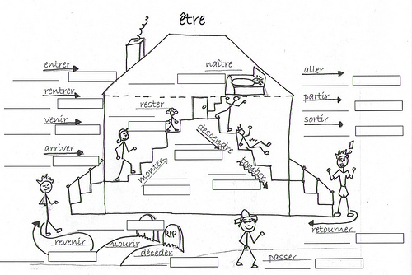

The verbs on the “La maison d’être” picture are conjugated with être in the passé compose. They are called verbes
de movement. The past participle agrees in GENDER (masculine or feminine) and NUMBER (singular or plural) with
the SUBJECT OF THE VERB.

